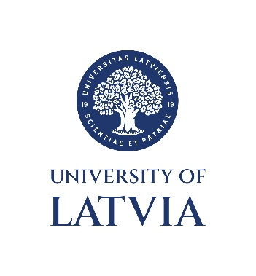
Faculty of Humanities
Department of Latvian and Baltic Studies

We invite you to submit an abstract to the
61st International Conference on Baltic Linguistics

Language Variations in Synchrony and Diachrony

The conference is dedicated to research on elements of the Baltic language and dialect system, examined from both synchronic and diachronic perspectives across various levels of linguistic analysis. Research topics and methodologies range from early texts and onomastics to sociolinguistics and computational linguistics.

The conference will take place on
March 27, 2026

Working languages: Latvian, Lithuanian, English, German

Please submit your application and an abstract (ca 250–300 words)
before March 1, 2026

You may wish to publish your paper in the journal Baltu filoloģija,
which is an internationally reviewed periodical

Our address:
Latvistikas un baltistikas nodaļa (221. kab.)
Humanitāro zinātņu fakultāte
Latvijas Universitāte
Visvalža 4A
Rīga LV-1050

e-mail:
lidija.leikuma@lu.lv
peteris.vanags@lu.lv
edmundas.trumpa@lu.lv

SUBMISSION FORM

First name, last name:

Title of paper:

Address, phone, e-mail:

Affiliation, Position, Title/Degree:

ABSTRACT
(ca 250–300 words)

